**Rabbit with Monocle Wall Mount**

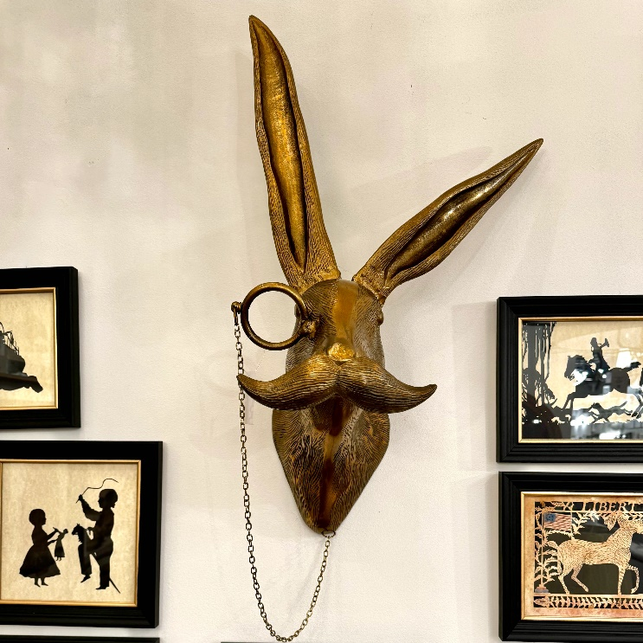The Rabbit with Monocle Wall Mount is a whimsical and sophisticated piece that adds a touch of quirky charm to any space. Featuring a highly detailed, taxidermy-inspired rabbit head, this mount is distinguished by the addition of a monocle, giving it a playful yet refined character. The blend of naturalistic elements and vintage style offers a delightful contrast, making it a standout focal point for any room. Perfect for eclectic, Victorian, or steampunk-inspired interiors, this wall mount brings an unexpected blend of humor and elegance, sparking conversation and admiration.